

**SINHGAD INSTITUTE OF TECHNOLOGY LONAVALA**

**SAVITRIBAI PHULE PUNE UNIVERSITY**

**A**

**PROJECT REPORT**

**ON**

**Project Title**

**SUBMITTED IN FULFILLMENT FOR SUBMISSION**

**OF**

**Skill Development Lab**

**SUBMITTED BY**

**Shubham Tormal[TEB 77]**

**Prathamesh Desai[TEB 69]**

**Tejashree Sonar[TEB 68]**

**Neha Pawar [TEB 78]**



**DEPARTMENT OF COMPUTER ENGINEERING**

**Sinhgad Institute of Technology, Kusgaon, Lonavala**

**Savitribai Phule Pune University**



**SINHGAD INSTITUTE OF TECHNOLOGYLONAVALA**

**SAVITRIBAI PHULE PUNE UNIVERSITY**

**CERTIFICATE**

This is certified that the Mini Project Entitled

**Health Care Management**

**SUBMITTED BY**

**Shubham Tormal[TEB 77]**

**Prathamesh Desai[TEB 69]**

**Tejashree Sonar[TEB 68]**

**Neha Pawar [TEB 78]**

**Prof. S. S. Shinde**

Subject Teacher

**Dr . S. D. Babar Dr. M. S. Gaikwad**

HOD Computer Engineering Principal

**Table of Contents**

1. **Introduction**
2. **Objective**
3. **Motivation**
4. **Project code**
5. **Steps to run the project**
6. **Screenshots**
7. **Advantages and Disadvantages**
8. **Conclusion**
9. **Introduction**

**Project Title: Total Health Care**

**Software Used: Android Studio**

**Main Features:**

1. **\*\* Weight Loss \*\***  
   **- Diet**  
   **- Exercise - Cardio - Strength Training - Yoga**  
   **- Routine Maker**  
   **- Workout Management**
2. **\*\* Skin Care \*\***  
   **- Acne / Pimples**  
   **- Scars**  
   **- Tan**  
   **- Sunburn**  
   **- Itching**  
   **- Face Care**
3. **\*\* Hair Care \*\***  
   **- Hair Loss**  
   **- Dandruff**  
   **- Itching**  
   **- Hair Growth**  
   **- Grey Hair**
4. **\*\* Body Care \*\***  
   **- Cold & Cough**  
   **- Stomach Ache**  
   **- Headache**  
   **- Back Pain**  
   - Joint Pain
5. **\*\* General Tips \*\***  
   **- Tips for Weight Loss**  
   **- Tips for Skin**  
   **- Tips for Hair**  
   **- Tips for Body**

**2**. **Objective**

***Over the past few years, living a healthy lifestyle has become trendy. Nowadays, being healthy means being beautiful, successful, and fit. People are becoming increasingly aware of diseases caused by obesity and sedentary office work.***

**Total Health Care App is produced by editors and journalists dedicated to delivering accurate, trusted, up-to-date health and medical information, for consumers. We focus on problem-solving content to help you make decisions during complicated, stressful times. We write in plain English, using real-life examples.**

**Through using gamification elements and creating competition among friends and family, fitness apps can help incentive users to be more motivated. Running and workout apps allow users to run or work out to music in the form of** [**DJ mixes**](https://en.wikipedia.org/wiki/DJ_mix) **that can be personalized based on the user's steps per minute, heart rate or ideal cadence thus boosting and enhancing performance during exercise.**

**The reason is probably that in 2014 health wasn’t such a popular topic. The general public didn’t think it was interesting. But everything changed in 2019, when the fitness industry took a gigantic leap. What was the reason for this drastic change? Wearables, of course. Wearables immediately became a trend, and as you can see, their popularity continues to increase:**

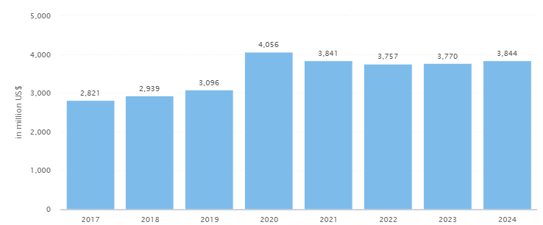

### **Nutrition:**



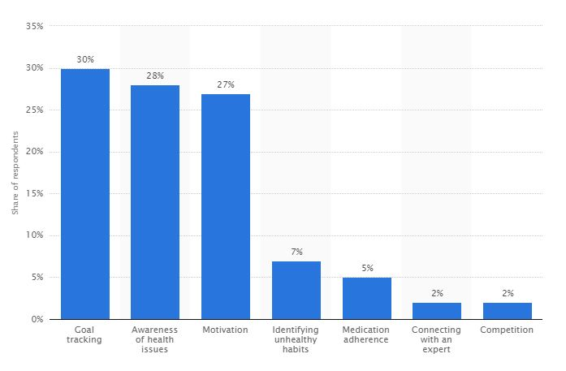

**3 .Motivation**

**Everybody likes to have a healthy lifestyle. But, it is not easy for everyone to follow a workout plan. A solution for such people may be an app that can help them reach their fitness targets. These kinds of apps have made the fitness and nutrition solutions readily available to all. But with so many apps on the market, it is not easy to pick the best one.**

**Here are some of the free download apps which are considered highly effective when it comes to your health and nutrition.**

## **1. START SLOWWWWLY.**

## **2. EXERCISE EVEN WHEN YOU DON’T FEEL LIKE IT**

## **3. OVERTHROW THE ‘STAY HERE ON THE SOFA’ GREMLIN**

## **4. PUT YOUR TRAINERS ON**

## **5. BUY SOME NEW TRAINING KIT**

## **6. SET A GOAL**

## **7. SCHEDULE FITNESS IN YOUR DIARY LIKE A MEETING**

## **8. GET A GOOD PLAYLIST**

## **9. IGNORE WHAT ANYONE ELSE SAYS**

## **10. IMAGINE YOURSELF AMAZING**

## **11. MAKE HEALTH AS IMPORTANT AS WORK**

**4.Project code**

**I . Android Manfest**

<?xml version="1.0" encoding="UTF-8"?>

-<manifest platformBuildVersionName="6.0-2438415" platformBuildVersionCode="23" package="com.galaxyskills.totalhealthcare" android:versionName="1.1" android:versionCode="1" xmlns:android="http://schemas.android.com/apk/res/android">

<uses-sdk android:targetSdkVersion="23" android:minSdkVersion="10"/>

<uses-permission android:name="android.permission.INTERNET"/>

<uses-permission android:name="android.permission.ACCESS_NETWORK_STATE"/>

<uses-permission android:name="android.permission.WAKE_LOCK"/>

-<application android:name="com.galaxyskills.totalhealthcare.AnalyticsApplication" android:supportsRtl="true" android:allowBackup="true" android:icon="@mipmap/ic_launcher" android:label="@string/app_name" android:theme="@style/AppTheme">

-<activity android:name="com.galaxyskills.totalhealthcare.MainActivity" android:label="@string/app_name" [android:theme="@style/AppTheme.NoActionBar](mailto:android:theme="@style/AppTheme.NoActionBar)">

-<intent-filter>

<action android:name="android.intent.action.MAIN"/>

<category android:name="android.intent.category.LAUNCHER"/>

</intent-filter>

</activity>

-<activity android:name="com.galaxyskills.totalhealthcare.DisplayActivity" android:label="@string/title_activity_display" [android:theme="@style/AppTheme.NoActionBar](mailto:android:theme="@style/AppTheme.NoActionBar)">

<meta-data android:name="android.support.PARENT_ACTIVITY" android:value="com.galaxyskills.totalhealthcare.MainActivity"/>

</activity>

-<activity android:name="com.galaxyskills.totalhealthcare.SubMainActivity" android:label="@string/title_activity_sub_main" [android:theme="@style/AppTheme.NoActionBar](mailto:android:theme="@style/AppTheme.NoActionBar)" android:parentActivityName="com.galaxyskills.totalhealthcare.MainActivity">

<meta-data android:name="android.support.PARENT_ACTIVITY" android:value="com.galaxyskills.totalhealthcare.MainActivity"/>

</activity>

<activity android:name="com.google.android.gms.ads.AdActivity" [android:theme="@style/Theme.Translucent](mailto:android:theme="@style/Theme.Translucent)" android:configChanges="keyboard|keyboardHidden|orientation|screenLayout|uiMode|screenSize|smallestScreenSize"/>

<activity android:name="com.google.android.gms.ads.purchase.InAppPurchaseActivity" [android:theme="@style/Theme.IAPTheme"/](mailto:android:theme="@style/Theme.IAPTheme"/)>

<meta-data android:name="com.google.android.gms.version" android:value="@integer/google_play_services_version"/>

<provider android:name="com.google.android.gms.measurement.AppMeasurementContentProvider" android:authorities="com.galaxyskills.totalhealthcare.google_measurement_service" android:exported="false"/>

-<receiver android:name="com.google.android.gms.measurement.AppMeasurementReceiver" android:enabled="true">

-<intent-filter>

<action android:name="com.google.android.gms.measurement.UPLOAD"/>

</intent-filter>

</receiver>

<service android:name="com.google.android.gms.measurement.AppMeasurementService" android:exported="false" android:enabled="true"/>

</application>

</manifest>

**II. Main Activity**

package com.galaxyskills.totalhealthcare;

import android.content.Intent;

import android.os.Bundle;

import android.support.p002v4.widget.DrawerLayout;

import android.support.p015v7.p016a.C0628u;

import android.support.p015v7.widget.GridLayoutManager;

import android.support.p015v7.widget.RecyclerView;

import android.support.p015v7.widget.Toolbar;

import android.view.MenuItem;

import android.view.View;

import com.google.android.gms.ads.AdView;

import com.google.android.gms.ads.C0991d;

import com.google.android.gms.ads.C0999f;

import com.google.android.gms.analytics.C1346r;

import com.google.android.gms.analytics.C1349u;

import java.util.ArrayList;

import java.util.List;

public class MainActivity extends C0628u implements C0917i {

/* renamed from: l */

private RecyclerView f2547l;

/* renamed from: m */

private C0916h f2548m;

/* renamed from: n */

private C1349u f2549n;

/* renamed from: a */

public void mo3808a(View view, int i) {

Intent intent = new Intent(this, SubMainActivity.class);

intent.putExtra("position", i);

startActivity(intent);

}

/* renamed from: k */

public List mo3809k() {

int i = 0;

ArrayList arrayList = new ArrayList();

int[] iArr = {R.drawable.menu_weight_loss, R.drawable.menu_skin_care, R.drawable.menu_hair_care, R.drawable.menu_body_care, R.drawable.menu_general_tips};

String[] strArr = {"Weight Loss", "Skin Care", "Hair Care", "Body Care", "General Tips"};

String[] strArr2 = {"#9ACD32", "#EE82EE", "#FF6347", "#F4A460", "#008080", "#000080", "#A0522D", "#9ACD32", "#EE82EE", "#FF6347", "#008080", "#A0522D", "#000080", "#00FF00", "#F4A460"};

while (i < iArr.length && i < strArr.length) {

C0919k kVar = new C0919k();

kVar.f2574a = iArr[i];

kVar.f2576c = strArr[i];

kVar.f2575b = strArr2[i];

arrayList.add(kVar);

i++;

}

return arrayList;

}

public void onBackPressed() {

DrawerLayout drawerLayout = (DrawerLayout) findViewById(R.id.drawer_layout);

if (drawerLayout.mo1547f(8388611)) {

drawerLayout.mo1546e(8388611);

} else {

super.onBackPressed();

}

}

/* access modifiers changed from: protected */

public void onCreate(Bundle bundle) {

super.onCreate(bundle);

setContentView((int) R.layout.activity_main);

mo1959a((Toolbar) findViewById(R.id.toolbar));

((AdView) findViewById(R.id.adView_Main)).mo3926a(new C0999f().mo4043b(C0991d.f2735a).mo4043b("9C46B58B08C09F8F8855A6F26D5505AE").mo4043b("B0AC5D5C92F726B01B5F1F2A9EE9820").mo4036a());

this.f2547l = (RecyclerView) findViewById(R.id.recyclerView_main);

this.f2548m = new C0916h(this, mo3809k());

this.f2548m.mo3818a((C0917i) this);

this.f2547l.setLayoutManager(new GridLayoutManager(this, 2));

this.f2547l.setAdapter(this.f2548m);

this.f2549n = ((AnalyticsApplication) getApplication()).mo3806a();

}

public boolean onOptionsItemSelected(MenuItem menuItem) {

menuItem.getItemId();

return super.onOptionsItemSelected(menuItem);

}

/* access modifiers changed from: protected */

public void onResume() {

super.onResume();

this.f2549n.mo5215a("Home Page");

this.f2549n.mo5217a(new C1346r().mo5206a());

}

}

**III.Sub MainActivity**

package com.galaxyskills.totalhealthcare;

import android.content.Intent;

import android.os.Bundle;

import android.support.p002v4.widget.DrawerLayout;

import android.support.p015v7.p016a.C0628u;

import android.support.p015v7.widget.GridLayoutManager;

import android.support.p015v7.widget.RecyclerView;

import android.support.p015v7.widget.Toolbar;

import android.view.MenuItem;

import android.view.View;

import com.google.android.gms.ads.AdView;

import com.google.android.gms.ads.C0991d;

import com.google.android.gms.ads.C0999f;

import com.google.android.gms.analytics.C1346r;

import com.google.android.gms.analytics.C1349u;

import java.util.ArrayList;

import java.util.List;

public class SubMainActivity extends C0628u implements C0917i {

/* renamed from: l */

String[] f2550l = {"#9ACD32", "#EE82EE", "#FF6347", "#F4A460", "#008080", "#000080", "#A0522D", "#9ACD32", "#EE82EE", "#FF6347", "#008080", "#A0522D", "#000080", "#00FF00", "#F4A460"};

/* renamed from: m */

private RecyclerView f2551m;

/* renamed from: n */

private C1349u f2552n;

/* renamed from: o */

private C0916h f2553o;

/* renamed from: p */

private String[] f2554p = {"Weight Loss", "Skin Care", "Hair Care", "Body Care", "General Tips", "Pain Solutions"};

/* renamed from: q */

private int f2555q;

/* renamed from: r */

private boolean f2556r = false;

/* renamed from: s */

private Toolbar f2557s;

/* renamed from: t */

private int f2558t = -1;

/* renamed from: a */

public void mo3808a(View view, int i) {

Intent intent = new Intent(this, DisplayActivity.class);

if (this.f2555q == 0 && i == 1 && this.f2558t == -1) {

this.f2558t = i;

this.f2553o.mo3820a(mo3812l());

this.f2556r = true;

this.f2557s.setTitle((CharSequence) "Exercise");

return;

}

intent.putExtra("positionMainMenu", this.f2555q);

if (this.f2555q != 0 || this.f2558t == -1) {

intent.putExtra("position", i);

intent.putExtra("subposition", -1);

} else {

intent.putExtra("position", this.f2558t);

intent.putExtra("subposition", i);

}

startActivity(intent);

}

/* renamed from: k */

public List mo3811k() {

ArrayList arrayList = new ArrayList();

int[][] iArr = {new int[]{R.drawable.sub_menu_diet, R.drawable.sub_menu_exercise2, R.drawable.sub_menu_routine_maker, R.drawable.sub_menu_workout_management}, new int[]{R.drawable.menu_skin_care, R.drawable.sub_menu_scars, R.drawable.sub_menu_tan_and_sunburn, R.drawable.sub_menu_burns, R.drawable.menu_body_care, R.drawable.sub_menu_face}, new int[]{R.drawable.sub_menu_hair_loss, R.drawable.sub_menu_dandruff, R.drawable.sub_menu_headache, R.drawable.sub_menu_hair_growth, R.drawable.sub_menu_grey_hair}, new int[]{R.drawable.sub_menu_cough_and_cold, R.drawable.sub_menu_stomach_ache, R.drawable.sub_menu_headache, R.drawable.sub_menu_back_ache, R.drawable.sub_menu_joint_pain}, new int[]{R.drawable.menu_weight_loss, R.drawable.menu_skin_care, R.drawable.menu_hair_care, R.drawable.menu_body_care}, new int[0]};

String[][] strArr = {new String[]{"Diet", "Exercise", "Routine Maker", "Workout Management"}, new String[]{"Acne/Pimples", "Scars", "Tan", "SunBurn", "Itching", "Face Care"}, new String[]{"Hair Loss", "Dandruff", "Itching", "Hair Growth", "Grey Hair"}, new String[]{"Cold & Cough", "Stomach Ache", "Headache", "Back Pain", "Joint Pain"}, new String[]{"Tips for Weight Loss", "Tips For Skin", "Tips for Hair", "Tips for Body"}, new String[]{""}};

for (int i = 0; i < strArr[this.f2555q].length; i++) {

C0919k kVar = new C0919k();

kVar.f2574a = iArr[this.f2555q][i];

kVar.f2576c = strArr[this.f2555q][i];

kVar.f2575b = this.f2550l[i];

arrayList.add(kVar);

}

return arrayList;

}

/* renamed from: l */

public List mo3812l() {

ArrayList arrayList = new ArrayList();

int[] iArr = {R.drawable.sub_sub_menu_cardio, R.drawable.sub_sub_menu_cardio, R.drawable.sub_sub_menu_strength_traning, R.drawable.sub_sub_menu_yoga};

String[][][] strArr = {new String[][]{new String[]{"Diet"}, new String[]{"Exercise", "Cardio", "Strength Training", "Yoga"}, new String[]{"Routine Maker"}, new String[]{"Workout Management"}}, new String[][]{new String[]{"Acne/Pimples"}, new String[]{"Scars"}, new String[]{"Tan"}, new String[]{"SunBurn"}, new String[]{"Itching"}, new String[]{"Face Care"}}, new String[][]{new String[]{"Hair Loss"}, new String[]{"Dandruff"}, new String[]{"Itching"}, new String[]{"Hair Growth"}, new String[]{"Grey Hair"}}, new String[][]{new String[]{"Cold & Cough"}, new String[]{"Stomach Ache"}, new String[]{"Headache"}, new String[]{"Back Pain"}, new String[]{"Joint Pain"}}, new String[][]{new String[]{"Tips for Weight Loss"}, new String[]{"Tips For Skin"}, new String[]{"Tips for Hair"}, new String[]{"Tips for Body"}}, new String[][]{new String[]{""}}};

for (int i = 1; i < strArr[this.f2555q][this.f2558t].length; i++) {

C0919k kVar = new C0919k();

kVar.f2574a = iArr[i];

kVar.f2576c = strArr[this.f2555q][this.f2558t][i];

kVar.f2575b = this.f2550l[i];

arrayList.add(kVar);

}

return arrayList;

}

public void onBackPressed() {

DrawerLayout drawerLayout = (DrawerLayout) findViewById(R.id.drawer_layout);

if (drawerLayout.mo1547f(8388611)) {

drawerLayout.mo1546e(8388611);

} else if (this.f2556r) {

this.f2553o.mo3820a(mo3811k());

this.f2556r = false;

this.f2558t = -1;

this.f2557s.setTitle((CharSequence) this.f2554p[this.f2555q]);

} else {

super.onBackPressed();

}

}

/* access modifiers changed from: protected */

public void onCreate(Bundle bundle) {

super.onCreate(bundle);

setContentView((int) R.layout.activity_sub_main);

this.f2557s = (Toolbar) findViewById(R.id.toolbar);

this.f2555q = getIntent().getIntExtra("position", -1);

if (this.f2555q != -1) {

this.f2557s.setTitle((CharSequence) this.f2554p[this.f2555q]);

}

mo1959a(this.f2557s);

try {

mo1965g().mo1793a(true);

} catch (Exception e) {

}

((AdView) findViewById(R.id.adView_SubMain)).mo3926a(new C0999f().mo4043b(C0991d.f2735a).mo4043b("9C46B58B08C09F8F8855A6F26D5505AE").mo4043b("B0AC5D5C92F726B01B5F1F2A9EE9820").mo4036a());

this.f2551m = (RecyclerView) findViewById(R.id.recyclerView_subMain);

this.f2553o = new C0916h(this, mo3811k());

this.f2553o.mo3818a((C0917i) this);

this.f2551m.setLayoutManager(new GridLayoutManager(this, 2));

this.f2551m.setAdapter(this.f2553o);

this.f2552n = ((AnalyticsApplication) getApplication()).mo3806a();

}

public boolean onOptionsItemSelected(MenuItem menuItem) {

if (menuItem.getItemId() != 16908332) {

return super.onOptionsItemSelected(menuItem);

}

finish();

return true;

}

/* access modifiers changed from: protected */

public void onResume() {

super.onResume();

if (this.f2555q != -1) {

this.f2552n.mo5215a("SubMenu - " + this.f2554p[this.f2555q]);

this.f2552n.mo5217a(new C1346r().mo5206a());

}

}

}

**IV . Display Activity**

package com.galaxyskills.totalhealthcare;

import android.os.Bundle;

import android.support.design.widget.FloatingActionButton;

import android.support.p002v4.view.ViewPager;

import android.support.p002v4.widget.DrawerLayout;

import android.support.p015v7.p016a.C0628u;

import android.support.p015v7.widget.Toolbar;

import android.view.MenuItem;

import com.galaxyskills.totalhealthcare.tabs.SlidingTabLayout;

import com.google.android.gms.ads.AdView;

import com.google.android.gms.ads.C0991d;

import com.google.android.gms.ads.C0999f;

import com.google.android.gms.analytics.C1346r;

import com.google.android.gms.analytics.C1349u;

public class DisplayActivity extends C0628u {

/* renamed from: m */

static String[][][] f2533m = {new String[][]{new String[]{"weight_loss/diet/diet1", "weight_loss/diet/diet2", "weight_loss/diet/diet3", "weight_loss/diet/diet4"}, new String[]{"Exercise", "Cardio", "Strength Training", "Yoga"}, new String[]{"weight_loss/routine_maker/routine_maker"}, new String[]{"weight_loss/workout_management/sample1", "weight_loss/workout_management/sample2", "weight_loss/workout_management/sample3"}}, new String[][]{new String[]{"skin_care/acne_pimples/ice", "skin_care/acne_pimples/lemon", "skin_care/acne_pimples/steam", "skin_care/acne_pimples/garlic", "skin_care/acne_pimples/honey_lemon"}, new String[]{"skin_care/scars/lemon_juice", "skin_care/scars/ice_cubes", "skin_care/scars/aloe_vera", "skin_care/scars/tea_tree_oil", "skin_care/scars/honey"}, new String[]{"skin_care/tan/remedy1", "skin_care/tan/remedy2", "skin_care/tan/remedy3", "skin_care/tan/remedy4", "skin_care/tan/remedy5"}, new String[]{"skin_care/sunburn/remedy1", "skin_care/sunburn/remedy2", "skin_care/sunburn/remedy3", "skin_care/sunburn/remedy4", "skin_care/sunburn/remedy5"}, new String[]{"skin_care/itching/remedy1", "skin_care/itching/remedy2", "skin_care/itching/remedy3", "skin_care/itching/remedy4"}, new String[]{"skin_care/face_care/face_mask1", "skin_care/face_care/face_mask2", "skin_care/face_care/face_mask3", "skin_care/face_care/face_mask4", "skin_care/face_care/face_mask5"}}, new String[][]{new String[]{"hair_care/hair_loss/hair_oil_massage", "hair_care/hair_loss/fenugreek", "hair_care/hair_loss/onion_juice", "hair_care/hair_loss/aloe_vera", "hair_care/hair_loss/healthy_diet"}, new String[]{"hair_care/dandruff/remedy1", "hair_care/dandruff/remedy2", "hair_care/dandruff/remedy3", "hair_care/dandruff/remedy4", "hair_care/dandruff/remedy5"}, new String[]{"hair_care/itching/lemon_juice", "hair_care/itching/baking_soda", "hair_care/itching/apple_cider_vinegar", "hair_care/itching/aloe_vera", "hair_care/itching/coconut_oil"}, new String[]{"hair_care/hair_growth/remedy1", "hair_care/hair_growth/remedy2", "hair_care/hair_growth/remedy3", "hair_care/hair_growth/remedy4", "hair_care/hair_growth/remedy5"}, new String[]{"hair_care/grey_hair/remedy1", "hair_care/grey_hair/remedy2", "hair_care/grey_hair/remedy3", "hair_care/grey_hair/remedy4", "hair_care/grey_hair/remedy5"}}, new String[][]{new String[]{"body_care/cold_cough/ginger_tea", "body_care/cold_cough/gargle_therapy", "body_care/cold_cough/water", "body_care/cold_cough/herbal_tea", "body_care/cold_cough/turmeric"}, new String[]{"body_care/stomach_ache/remedy1", "body_care/stomach_ache/remedy2", "body_care/stomach_ache/remedy3", "body_care/stomach_ache/remedy4", "body_care/stomach_ache/remedy5"}, new String[]{"body_care/headache/basil", "body_care/headache/ice_pack", "body_care/headache/cloves", "body_care/headache/coffee", "body_care/headache/yoga"}, new String[]{"body_care/back_pain/remedy1", "body_care/back_pain/remedy2", "body_care/back_pain/remedy3", "body_care/back_pain/remedy4", "body_care/back_pain/remedy5"}, new String[]{"body_care/joint_pain/remedy1", "body_care/joint_pain/remedy2", "body_care/joint_pain/remedy3", "body_care/joint_pain/remedy4", "body_care/joint_pain/remedy5"}}, new String[][]{new String[]{"general_tips/tips_weight_loss/weight_loss_tips"}, new String[]{"general_tips/tips_skin/skin_tips"}, new String[]{"general_tips/tips_hair/hair_tips"}, new String[]{"general_tips/tips_body/body_tips"}}, new String[][]{new String[]{""}}};

/* renamed from: o */

static String[][] f2534o = {new String[]{"weight_loss/exercise/cardio/walking", "weight_loss/exercise/cardio/swimming", "weight_loss/exercise/cardio/cycling", "weight_loss/exercise/cardio/running", "weight_loss/exercise/cardio/jumping_rope"}, new String[]{"weight_loss/exercise/strength_traning/pushup", "weight_loss/exercise/strength_traning/bridge", "weight_loss/exercise/strength_traning/squats", "weight_loss/exercise/strength_traning/walking_lunges", "weight_loss/exercise/strength_traning/superman_back_extension"}, new String[]{"weight_loss/exercise/yoga/suryanamaskar", "weight_loss/exercise/yoga/bhekasana", "weight_loss/exercise/yoga/dhanurasana", "weight_loss/exercise/yoga/salabhasana", "weight_loss/exercise/yoga/chakki_chalan"}};

/* renamed from: r */

private static int f2535r = 0;

/* access modifiers changed from: private */

/* renamed from: s */

public static int f2536s;

/* access modifiers changed from: private */

/* renamed from: t */

public static int f2537t;

/* renamed from: u */

private static int f2538u;

/* access modifiers changed from: private */

/* renamed from: v */

public static ViewPager f2539v;

/* renamed from: l */

String[][][] f2540l = {new String[][]{new String[]{"Diet 1", "Diet 2", "Diet 3", "Diet 4"}, new String[]{"Exercise", "Cardio", "Strength Training", "Yoga"}, new String[]{"Routine Maker"}, new String[]{"Sample 1", "Sample 2", "Sample 3"}}, new String[][]{new String[]{"Ice", "Lemon", "Steam", "Garlic", "Honey - Lemon"}, new String[]{"Lemon Juice", "Ice Cubes", "Aloe Vera", "Tea Tree Oil", "Honey"}, new String[]{"Remedy 1", "Remedy 2", "Remedy 3", "Remedy 4", "Remedy 5"}, new String[]{"Remedy 1", "Remedy 2", "Remedy 3", "Remedy 4", "Remedy 5"}, new String[]{"Remedy 1", "Remedy 2", "Remedy 3", "Remedy 4"}, new String[]{"Face Mask 1", "Face Mask 2", "Face Mask 3", "Face Mask 4", "Face Mask 5"}}, new String[][]{new String[]{"Hair Oil Massage", "Fenugreek", "Onion Juice", "Aloe vera", "Healthy Diet"}, new String[]{"Remedy 1", "Remedy 2", "Remedy 3", "Remedy 4", "Remedy 5"}, new String[]{"Lemon Juice", "Baking Soda", "Apple Cider Vinegar", "Aloe Vera", "Coconut Oil"}, new String[]{"Remedy 1", "Remedy 2", "Remedy 3", "Remedy 4", "Remedy 5"}, new String[]{"Remedy 1", "Remedy 2", "Remedy 3", "Remedy 4", "Remedy 5"}}, new String[][]{new String[]{"Ginger Tea", "Gargle Therapy", "Water", "Herbal tea", "Turmeric"}, new String[]{"Remedy 1", "Remedy 2", "Remedy 3", "Remedy 4", "Remedy 5"}, new String[]{"Basil", "Ice Pack", "Cloves", "Coffee", "Do yoga"}, new String[]{"Remedy 1", "Remedy 2", "Remedy 3", "Remedy 4", "Remedy 5"}, new String[]{"Remedy 1", "Remedy 2", "Remedy 3", "Remedy 4", "Remedy 5"}}, new String[][]{new String[]{"Weight Loss Tips"}, new String[]{"Skin Care Tips"}, new String[]{"Hair Care Tips"}, new String[]{"Body Care Tips"}}, new String[][]{new String[]{""}}};

/* renamed from: n */

String[][] f2541n = {new String[]{"Walking", "Swimming", "Cycling", "Running", "Jumping rope"}, new String[]{"Push-Up", "Bridge", "Squats", "Walking Lunges", "Superman Back Extension"}, new String[]{"SuryaNamaskar", "Bhekasana", "Dhanurasana", "Shalabhasana", "Chakki Chalanasana"}};

/* renamed from: p */

String[][][] f2542p = {new String[][]{new String[]{"Diet"}, new String[]{"Exercise", "Cardio", "Strength Training", "Yoga"}, new String[]{"Routine Maker"}, new String[]{"Workout Management"}}, new String[][]{new String[]{"Acne/Pimples"}, new String[]{"Scars"}, new String[]{"Tan"}, new String[]{"SunBurn"}, new String[]{"Itching"}, new String[]{"Face Care"}}, new String[][]{new String[]{"Hair Loss"}, new String[]{"Dandruff"}, new String[]{"Itching"}, new String[]{"Hair Growth"}, new String[]{"Grey Hair"}}, new String[][]{new String[]{"Cold & Cough"}, new String[]{"Stomach Ache"}, new String[]{"Headache"}, new String[]{"Back Pain"}, new String[]{"Joint Pain"}}, new String[][]{new String[]{"Tips for Weight Loss"}, new String[]{"Tips For Skin"}, new String[]{"Tips for Hair"}, new String[]{"Tips for Body"}}, new String[][]{new String[]{""}}};

/* renamed from: q */

String[] f2543q = {"Weight Loss", "Skin Care", "Hair Care", "Body Care", "General Tips"};

/* renamed from: w */

private SlidingTabLayout f2544w;

/* access modifiers changed from: private */

/* renamed from: x */

public FloatingActionButton f2545x;

/* renamed from: y */

private C1349u f2546y;

public void onBackPressed() {

DrawerLayout drawerLayout = (DrawerLayout) findViewById(R.id.drawer_layout);

if (drawerLayout.mo1547f(8388611)) {

drawerLayout.mo1546e(8388611);

} else {

super.onBackPressed();

}

}

/* access modifiers changed from: protected */

public void onCreate(Bundle bundle) {

super.onCreate(bundle);

setContentView((int) R.layout.activity_display);

Toolbar toolbar = (Toolbar) findViewById(R.id.toolbar);

f2536s = getIntent().getIntExtra("positionMainMenu", -1);

f2537t = getIntent().getIntExtra("position", -1);

f2538u = getIntent().getIntExtra("subposition", -1);

if (f2538u != -1 && f2536s == 0 && f2537t == 1) {

this.f2540l[f2536s][f2537t] = this.f2541n[f2538u];

f2533m[f2536s][f2537t] = f2534o[f2538u];

}

if (!(f2537t == -1 || f2536s == -1)) {

if (f2538u != -1 && f2536s == 0 && f2537t == 1) {

toolbar.setTitle((CharSequence) this.f2542p[f2536s][f2537t][f2538u + 1]);

} else {

toolbar.setTitle((CharSequence) this.f2542p[f2536s][f2537t][0]);

}

}

mo1959a(toolbar);

try {

mo1965g().mo1793a(true);

} catch (Exception e) {

}

f2539v = (ViewPager) findViewById(R.id.pager);

f2539v.setAdapter(new C0913e(this, mo820f()));

this.f2544w = (SlidingTabLayout) findViewById(R.id.tabs);

this.f2544w.setDistributeEvenly(true);

this.f2544w.setViewPager(f2539v);

this.f2545x = (FloatingActionButton) findViewById(R.id.fab);

AdView adView = (AdView) findViewById(R.id.adView_Display);

C0991d a = new C0999f().mo4043b(C0991d.f2735a).mo4043b("9C46B58B08C09F8F8855A6F26D5505AE").mo4043b("B0AC5D5C92F726B01B5F1F2A9EE9820").mo4036a();

adView.setAdListener(new C0909a(this, adView));

adView.mo3926a(a);

if (f2536s == 4) {

this.f2545x.setVisibility(4);

} else {

this.f2545x.setVisibility(0);

}

this.f2545x.setOnClickListener(new C0910b(this));

this.f2546y = ((AnalyticsApplication) getApplication()).mo3806a();

}

public boolean onOptionsItemSelected(MenuItem menuItem) {

if (menuItem.getItemId() != 16908332) {

return super.onOptionsItemSelected(menuItem);

}

finish();

return true;

}

/* access modifiers changed from: protected */

public void onResume() {

super.onResume();

if (f2537t != -1 && f2536s != -1) {

if (f2538u != -1 && f2536s == 0 && f2537t == 1) {

this.f2546y.mo5215a(this.f2543q[f2536s] + " - Exercise - " + this.f2542p[f2536s][f2537t][f2538u + 1]);

this.f2546y.mo5217a(new C1346r().mo5206a());

return;

}

this.f2546y.mo5215a(this.f2543q[f2536s] + " - " + this.f2542p[f2536s][f2537t][0]);

this.f2546y.mo5217a(new C1346r().mo5206a());

}

}

}

**6**.**Steps to run the project**

# **Run your app:**

## Run on a real device

Set up your device as follows:

1.Connect your device to your development machine with a USB cable. If you developed on Windows, you might need to [install the appropriate USB driver](https://developer.android.com/studio/run/oem-usb) for your device.

2.Perform the following steps to enable **USB debugging** in the **Developer options** window:

* 1. Open the **Settings** app.
  2. If your device uses Android v8.0 or higher, select **System**. Otherwise, proceed to the next step.
  3. Scroll to the bottom and select **About phone**.
  4. Scroll to the bottom and tap **Build number** seven times.
  5. Return to the previous screen, scroll to the bottom, and tap **Developer options**.
  6. In the **Developer options** window, scroll down to find and enable **USB debugging**.

Run the app on your device as follows:

1.In Android Studio, select your app from the run/debug configurations drop-down menu in the toolbar.

2.In the toolbar, select the device that you want to run your app on from the target device drop-down menu.

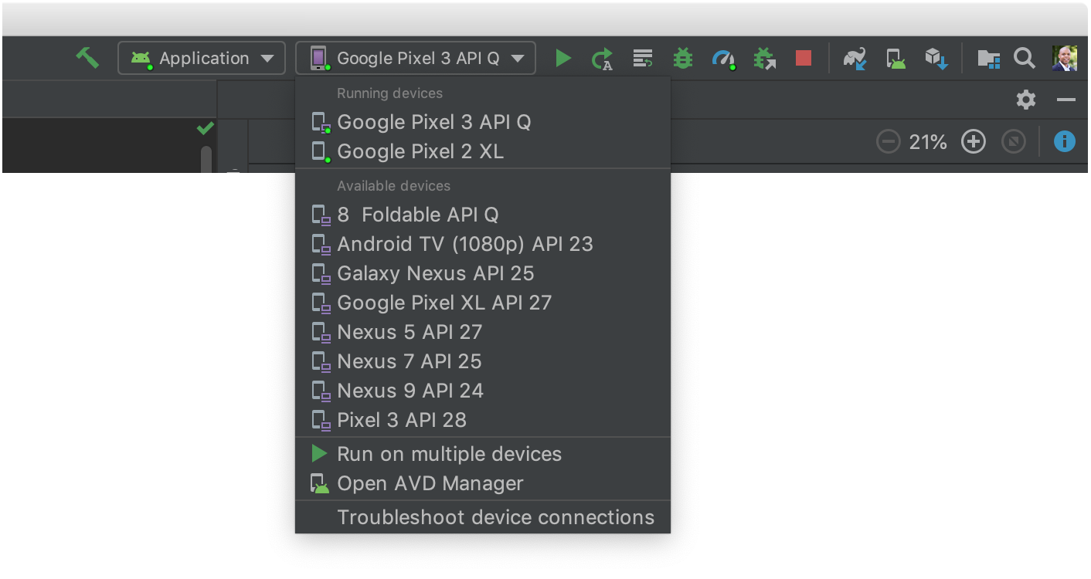

**Figure 1.** Target device drop-down menu

3.Click **Run** .

4.Android Studio installs your app on your connected device and starts it. You now see "Hello, World!" displayed in the app on your device.

To begin to develop your app, continue to the [next lesson](https://developer.android.com/training/basics/firstapp/building-ui).

## Run on an emulator

Run the app on an emulator as follows:

5.In Android Studio, [create an Android Virtual Device (AVD)](https://developer.android.com/studio/run/managing-avds#createavd) that the emulator can use to install and run your app.

6.In the toolbar, select your app from the run/debug configurations drop-down menu.

7.From the target device drop-down menu, select the AVD that you want to run your app on.

8.

1. **Figure 2.** Target device drop-down menu
2. Click **Run** .
3. Android Studio installs the app on the AVD and starts the emulator. You now see "Total Health Care!" displayed in the app.

**Screenshots**

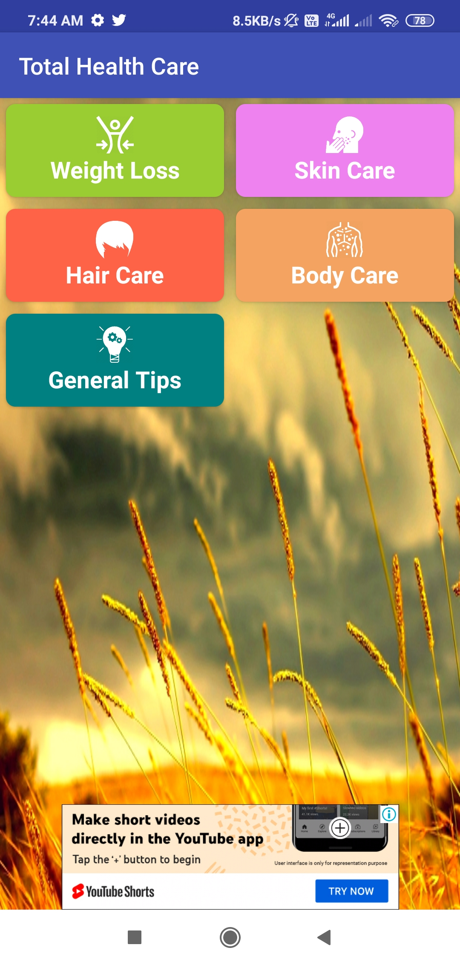

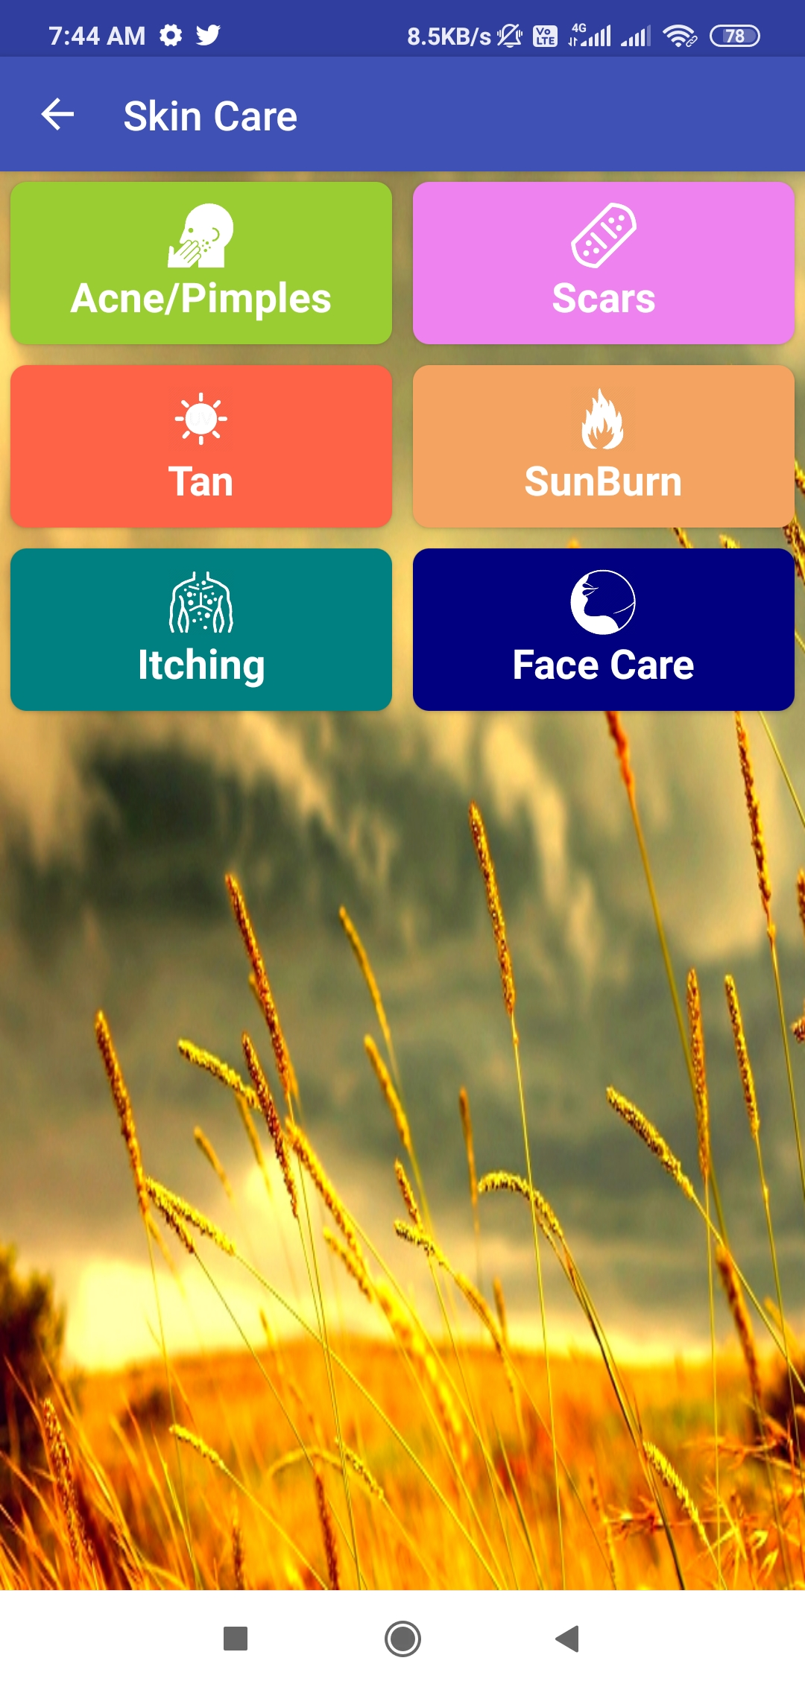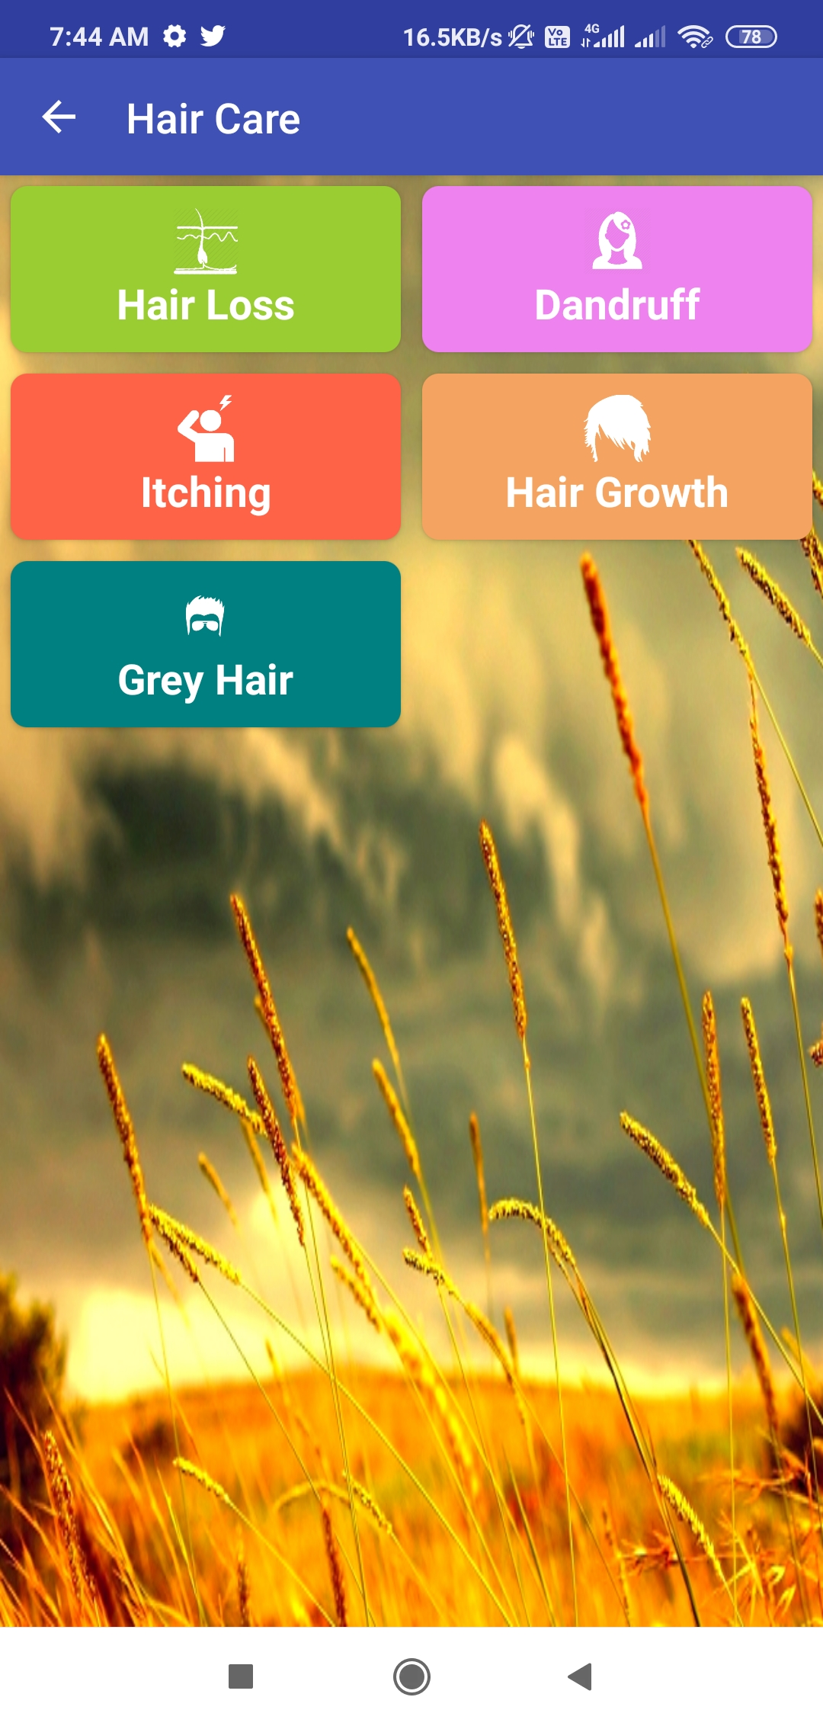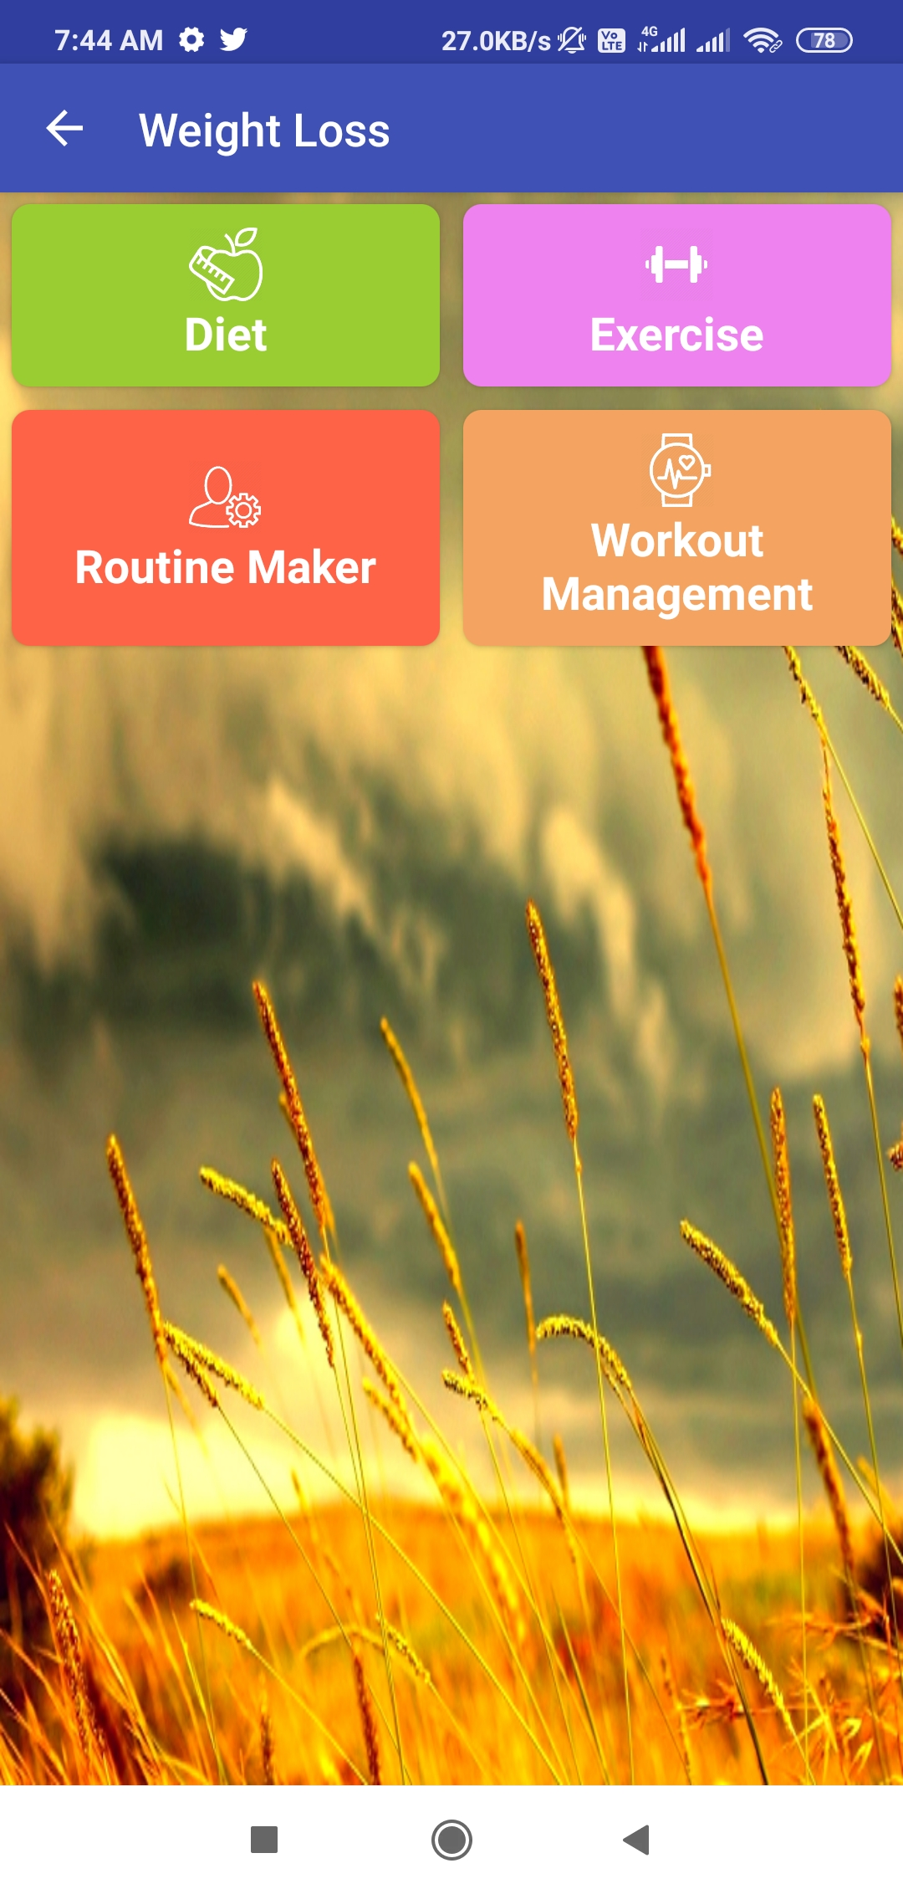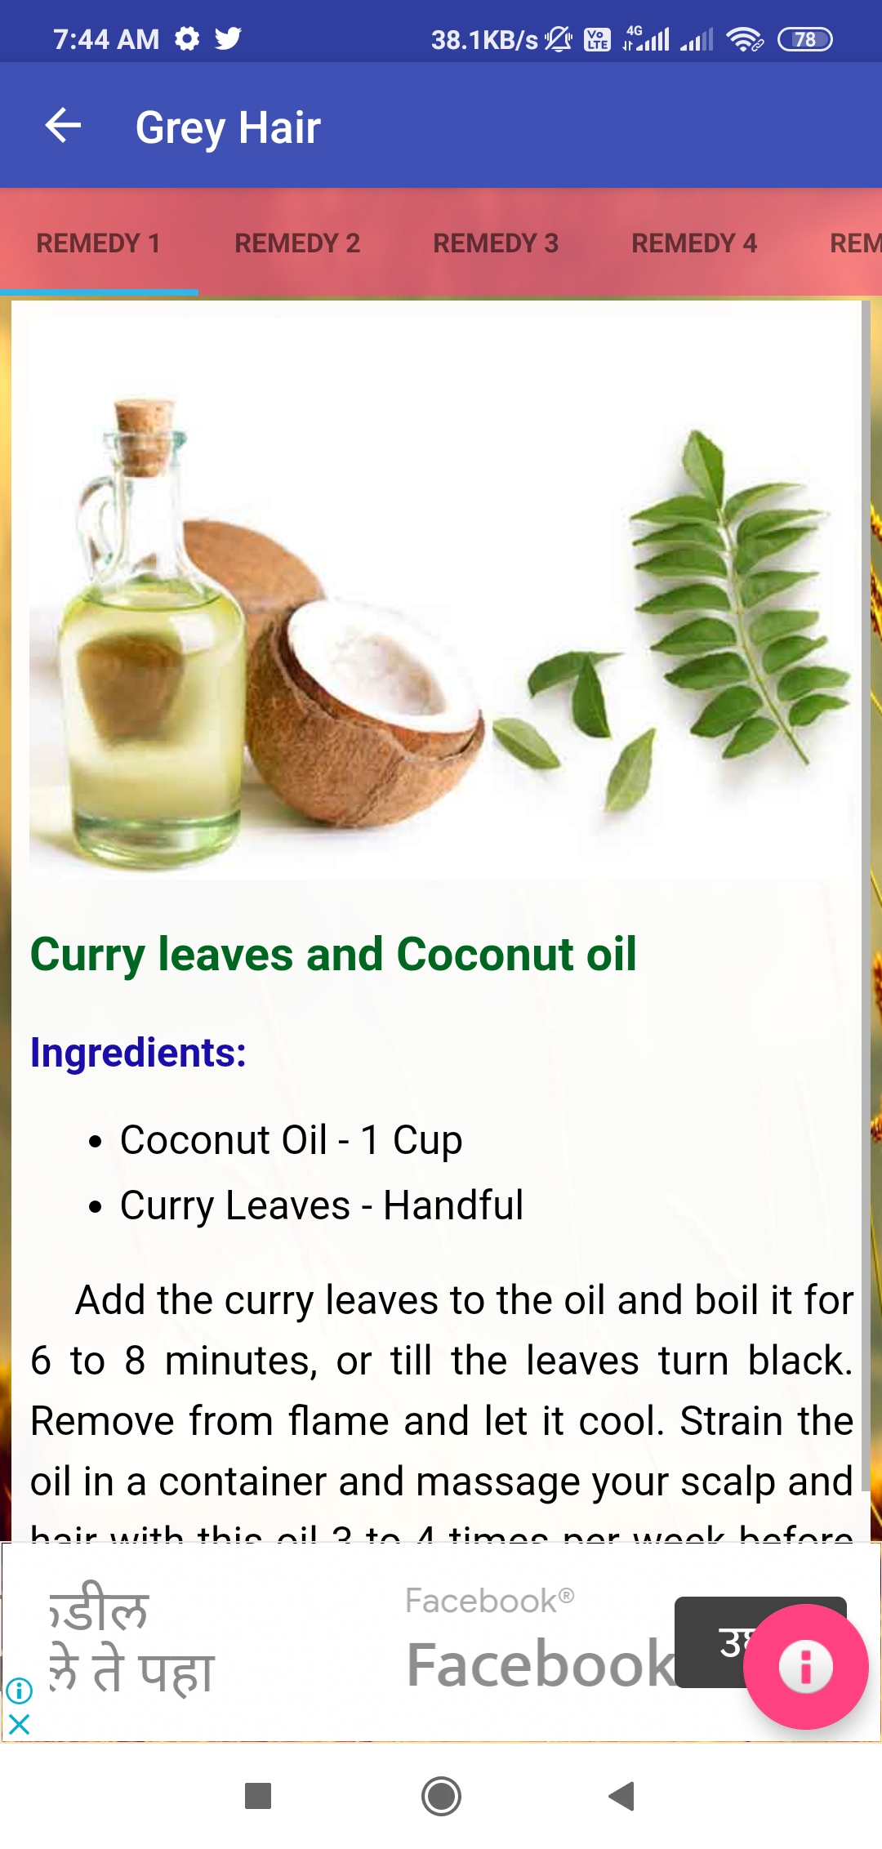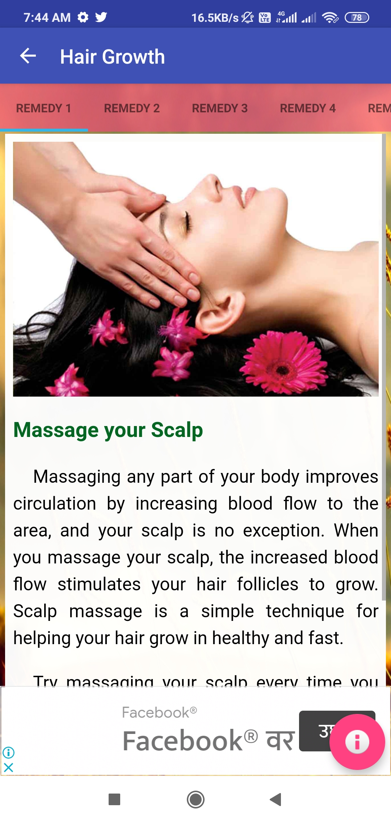

7.**Advantages and Disadvantages**

Let's start by breaking down the most prominent pros, all of which revolve around ease and awareness:

* **Convenience.** meaning more people have the ability to monitor and manage their health on the go. Many mHealth apps are available to download for free or at a minimal cost, and some allow users to set pill or appointment reminders, access their medical records in real time, or view post-visit instructions.
* **Encouraging healthy behavior.** "[correlate personal decisions with health outcomes](http://bits.blogs.nytimes.com/2015/04/14/report-questions-whether-health-apps-benefit-healthy-people/?_r=0)" and help doctors [keep patients accountable](http://dignityhealth.org/cm/content/pages/strategies-to-ensure-patient-follow-up-with-lifestyle-changes.asp) for their behavior.
* **Education.** Certain health apps can be informative and educational. There are apps for medical reference, terminology, and anatomy, as well as apps that help identify prescription drugs. Some apps also enable access to medical journals and other literature.

But what about the other side of the coin? Here are three cons that have doctors and health officials worried about mobile health apps:

* **Data privacy.** Many health apps raise data privacy concerns. In 2013, Privacy Rights Clearinghouse, a nonprofit advocacy organization in San Francisco, analyzed 43 free and paid apps, finding that 72 percent of them [exposed personal information](http://www.amednews.com/article/20130805/business/130809993/7/?utm_source=feedly) such as dates of birth, email addresses, and medical information. Only half of the apps linked to a privacy policy, which typically explains what personal information is gathered and if data is shared with or sold to third parties and why. The study also found that paid apps posed less of a risk to users' privacy, likely because they do not rely on advertisers to make money.
* **Inaccurate information.** Some apps claim to be able to measure a user's heart rate and stress levels using a sensor beneath the phone's camera. Others claim to be able to measure blood pressure using the phone's screen or camera. When tested, these apps often give varying results or cannot get a reading at all, but rarely is there a warning that [the information provided is untested and potentially unreliable](http://www.wired.com/2014/07/medical_apps/). If a user looks closer, however, they might find a warning that the app is intended for "recreational use only."
* **Lack of regulation and approval.** A study published in the *Journal of the American Society of Hypertension* found that only 3 percent of the top 107 apps found using the terms "hypertension" and "high blood pressure" were [developed by health care agencies](http://www.reuters.com/article/us-bp-apps-idUSKBN0K11QF20141223). None of the apps had been approved by the FDA, although 14 percent could turn into a medical device to measure blood pressure. The authors of the study concluded that such apps reveal an "urgent need for greater regulation and oversight in medical app development."

It is important to exercise discretion and common sense when using mobile health apps -- and your patient base needs to understand this. Be sure to have them review any privacy policies to see how their information may be used and whether the app has been approved or is regulated by the FDA. Encourage them to read the disclaimers, if any, to find out if the app is intended for entertainment or recreational use, as well.

In the end, you can't control what your patients are looking at on their phones, but you can encourage them to treat any health info gleaned from these apps with caution and a fair amount of doubt.

# **8.Conclusions**

Health care is moving into the home increasingly often and involving a mixture of people, a variety of tasks, and a broad diversity of devices and technologies; it is also occurring in a range of residential environments. The factors driving this migration include the rising costs of providing health care; the growing numbers of older adults; the increasing prevalence of chronic disease; improved survival rates of various diseases, injuries, and other conditions (including those of fragile newborns); large numbers of veterans returning from war with serious injuries; and a wide range of technological innovations. The health care that results varies considerably in its safety, effectiveness, and efficiency, as well as its quality and cost.

**HEALTH CARE TECHNOLOGIES**

Health care technologies include medical devices that are used in the home as well as information technologies related to home-based health care. The four recommendations in this area concern (1) regulating technologies for health care consumers, (2) developing guidance on the structure and usability of health information technologies, (3) developing guidance and standards for medical device labeling, and (4) improving adverse event reporting systems for medical devices. The adoption of these recommendations would improve the usability and effectiveness of technology systems and devices, support users in understanding and learning to use them, and improve feedback to government and industry that could be used to further improve technology for home care.

**Guidance and Standards**

Developers of information technologies related to home-based health care, as yet, have inadequate or incomplete guidance regarding product content, structure, accessibility, and usability to inform innovation or evolution of personal health records or of care recipient access to information in electronic health records.

The ONC, in the initial announcement of its health information technology certification program, stated that requirements would be forthcoming with respect both to personal health records and to care recipient access to information in electronic health records (e.g., patient portals). Despite the importance of these requirements, there is still no guidance on the content of information that should be provided to patients or minimum standards for accessibility, functionality, and usability of that information in electronic or nonelectronic formats.

**Live Long ,Stay Healthy**

**-Thank You-**